IOT BASED FAULT INDICATION . SYSTEM

## A REPORT

**JIT1731: PROJECT PHASE-2**

## III YEAR / VI SEM

***Submitted by***

|  |  |  |
| --- | --- | --- |
| **SAKTHIDHASAN.K** | **-** | **[130720205305]** |
| **DHILIP KUMAR.D** | **-** | **[130720205303]** |

***in partial fulfillment for the award of the degree***

***of***

## BACHELOR OF TECHNOLOGY

**In**

## INFORMATION TECHNOLOGY



**JERUSALEM COLLEGE OF ENGINEERING**

**(An Autonomous Institution, Affiliated to Anna University, Chennai)**

NBA & NAAC ACCREDITED INSTITUTION

Velachery main road, Narayanapuram, Pallikaranai, Chennai - 600100

**MARCH 2023**

BONAFIDE CERTIFICATE

Certified that this Report titled “**IOT BASED FAULT DETECTION INDICATION SYSTEM**” is the bonafide work of **SAKTHIDHASAN.K(130720205305),DHILIPKUMAR.D(13072020303)**Who carried out the work under my supervision. Certified further that to the best of my knowledge the work reported herein does not form part of any other thesis or dissertation on the basis of which a degree or award was conferred on an earlier occasion on this or any other candidate.

**SIGNATURE SIGNATURE**

**Mr.KUMAR PAROP GOPAL Dr.K.SUNDARAMOORTHY**

Assistant Professor Professor and Head Department of Information Technology Department of Information IT

Jerusalem College of Engineering Jerusalem College of Engineering

Submitted to the project viva- voce exam held-on ………………..

**INTERNAL EXAMINER EXTERNAL EXAMINER**

**ACKNOWLEDGEMENT**

We would like to extend our sincere thanks and deep sense of gratitude to our honourable CEO Prof.(**Dr.) M.MALA, M.A., M.Phil.,**and our director **Dr.M.RAMALINGAM,** and our Principal,**Dr.S.Ramesh**, **M.Tech.,**for providing us the entire infrastructure required to complete our project without any difficulty.

We find no words to express our deep sense of gratitude to **Dr.K.Sundaramoorthy,** Professor, Head of the Department, Information Technology, for being a constant source of inspiration throughout the course our project successfully.

We thank our Project Coordinator **Mrs. K.Pushpavalli**,,**M.Tech**, Assistant Professor, for their advice and assistance in keeping our progress on schedule.

We would like to take this opportunity to express our sincere thanks to our internal guide **Mrs.CRISTY GRACE**, **M.Tech,** Assistant Professor, Information Technology, for her valuable guidance and technical support in our project work.

Our grateful thanks are also extended to all our department faculty members for their valuable technical support on this project. Finally, we thank almighty, our parents and friends for their constant encouragement without which this project work would not be possible.

SAKTHIDHASAN.K DHILIP KUMAR.D

## TABLE OF CONTENTS

**CHAPTER TITLLE PAGE.NO**

# INTRODUCTION

* 1. OBJECTIVE 1
  2. AIM 2
  3. IOT 2

1. LITERATURE SURVEY

2.0 INTRODUCTION 4

2.1 AGING MECHANISMS IN CIRCUIT WIIRES 5

2.2 METHODOLOGY 6

1. MOTIVATIONAL BACKGROUND 
   1. REDUCED HUMAN EFFORT 7
   2. LESS MAINTENANCE 8
   3. PROTECTING EQUIPMENT 9
   4. IDENTIFY FAULT LOCATION 10
2. PROPOSED SYSTEMS
   1. BLOCK DIAGRAM 11
   2. FLOW DIAGRAM/FLOW CHART 12
   3. CIRCUIT DIAGRAM 13
3. IMPLEMENTATION DETAILS
   1. HARDWARE DESCRIPTION 15
   2. SOFTWARE DESCRIPTION 16
   3. ARDUINO IDE 17
   4. SIMULATION DIAGRAM 18
4. ADVANTAGES & APPLICATION 20

DETECTS ACCURATE FAULT SUB LOCATION

TIME SAVING & COST EFFECTIVE

## COMPONENTS AND WORKING

* 1. MICROCONTROLER 21
  2. SENSORS 22
  3. LCD DISPLAY 23
  4. SYSTEM OVERVIEW 24

## CONCLUSION & FUTURE SCOPE

8.1 CONCLUSION 26

8.2 FUTURE SCOPE 27

8.3 REFERENCES 28

**ABSTRACT**

Fault in power systems is one of the greatest problems that cause power disruptions. It can occur from generation, distribution, and consumer systems. This project will focus mainly on the Building line fault Building cables are used more often in urban areas than overhead lines. It is difficult to locate a fault when it occurs, and the process may be time-consuming and costly. The proposed system will find the exact location of the fault and facilitate timely maintenance. The concept of a potential divider network connected across the Building line will be used. IoT will allow the authority to check faults over the internet while in their respective Transformers. Therefore, they can alert the technicians who are near the particular location for repair. A set of resistors represents the length of the cable in floors, and faults are created at predefined distances using switches. In case of a fault, there will be a change in current drops, which will be sent to the microcontroller. The ADC in the microcontroller interprets the data and conveys the information to the user in terms of distance in floors. This is then displayed over the LCD and shared online using the IoT platform.

## CHAPTER – 1

1. **OBJECTIVE**

The objective is to determine the cable fault and its location using IOT and microcontroller board. In the present scenario when a fault occurs, detecting fault source is difficult and entire line has to be dug in order to check entire line and fix faults. The main objective is to detect the fault nearby location to reduce the time. So, it avoids the difficulty in digging the entire line. The basic idea is to read the voltage using sub unit from different place. Hence it will detect the fault with help of sub unit. In this implementation we are using 3 sub units in transmission line and with help of switch we are creating transmission line. Once any fault occurs, from that point the next sub unit will not able to update status. So fault will be from that point to next sub unit. We will able to see the status

## AIM

fault position over IOT that makes repairing work very easy. The repairmen know exactly which part has fault and only that area is to be dug to detect the fault source. This saves a lot of time, money and efforts and also allows to service underground cables faster. We use IOT technology that updates the monitored fault information to internet. The system detects fault with the help of potential divider network laid across the cable. Whenever a fault gets created at a point shorting two lines together, a specific voltage gets generated as per the resistors network combination. This voltage is sensed by the microcontroller and is updated to the user. The information conveyed to the user is the information regarding faults detection..

## IOT

Power supply networks are growing continuously and their reliability getting more important than ever. The complexity of the whole network comprises numerous components that can fail and interrupt the power supply for end user. For most of the worldwide operated low voltage and medium voltage distribution lines, underground cables have been used for many decades. Underground high voltage cables are used more and more because they are not influenced by weather conditions, heavy rain, storm, snow and pollution. Even though the Cable manufacturing technology is improving steadily, there are still influences which may cause cable to fail during test and operation. A cable in good condition and installed correctly can last a lifetime of about of all unit in a common IOT app from anywhere around the world. The paper work is intended to detect the fault in underground cable lines from the base station to another substation using a Microcontroller. To locate a fault in the cable, the cable must be tested for faults and fault creation is made by a set of switches at every known distance between two substations. In case of fault, the voltage drops and changes accordingly, which is then fed to a programmed microcontroller IC that further displays on IOT fault. IOT is used to display the information over Internet using the Wi-Fi module ESP8266. A webpage is created using HTML coding and the information about occurrence of fault is displayed in a webpage or also can use android application for same.

While a fault occurs due to many reasons in the cable, at a time of removing or repairing process, there is difficulty in locating also nearby location of the fault. The system proposed in this project is used to find out the sub area location of the fault and display it to the dedicated application over internet using Wi-Fi module.

## CHAPTER – 2

## INTRODUTION

This project is to determine the distance of underground cable fault from the base station in kilometres and displayed over the internet. Underground cable system is a common followed in major areas in Metro cities. While a fault occurs for some reason, at that time the fixing process related to that particular cable is difficult due to exact unknown location of the fault in the cable. This Technology is used to find out the exact location of the fault and to send data in graphical format to our website using a GSM module at the same time it display on the LCD screen.

The project uses the standard theory of Ohms law, i.e., when a low DC voltage is applied at the feeder end through a series resistor (Cable lines),then the current would vary depending upon the location of the fault in the cable as the resistance is proportional to the distance. In case there is a short circuit (Line to Ground), the voltage across series resistors changes according to the resistance that changes with distance .This is then fed to an ADC to develop precise digital data which the programmed microcontroller of the 8051 family displays in kilometres.  Whenever a fault gets created at a point shorting two lines together, a specific voltage gets generated as per the resistors network combination. This voltage is sensed by the microcontroller and is updated to the user. The information conveyed to the user is the information regarding faults detection.

## 

## 2.1. AGING MECHANISMS IN CIRCUIT WIRES

The circuit consists of a power supply, 4 line display, arduino and resistance measurement circuit. To induce faults manually in the kit, fault switches are used. About 12 fault switches are used which are arranged in three rows with each row having 4 switches. The 3 rows represent the 3 phases namely R,Y and B. The fault switches have 2 positions-No fault position(NF) and fault position(F).Main component of the underground cable fault detection circuit is low value resistance measurement. It is constructed using a constant current source of 100mAmps. It can measure very low value resistance as the cables have around 0.01 Ohm/meter resistance. For 10meter cable resistance becomes 0.1 Ohm. This circuit can measure resistance up 50 Ohm, Maximum cable length it can check up to 4 kilometres.

So starting from the reference point 3 sets of resistances are placed in series. These 3 sets of resistances represent the three phases and the neutral. Short circuit faults, Symmetrical and unsymmetrical faults can be determined by this method. This project uses three set of resistances in series (ie)R10R11-R12- R12,R17-R16-R14R21,R20-R19-R18-R25 one for each phase

One relay for each phase R,Y and B as three relays are used and the common points of the relays are grounded and the NO points are connected to the inputs of R17,R21 and R25 and being the three phase cable input. As supply needed for the relays is higher than that of the arduino, Relay driver is used to boost the supply and provide it to the relays. A 230V AC supply is applied to the transformer from where it is stepped down to 12V AC From the transformer the alternating current gets converted into direct current when it passes through a Bridge wave rectifier .The 12V DC then goes to the voltage regulator where it gets converted from 12V DC to 5V DC Voltage regulator is used also converts the variable Dc supply into constant DC supply. This 5V DC is used to supply power to the arduino and the LCD Power supply to the LCD is given from the voltage regulator.

12 switches (to F position),they impose conditions like LG,LL,LLG fault as per the switch operation. As a result of the fault, there is a change in voltage value. This voltage value measured across the resistance is fed to the ADC of the Arduino. Using this value, the arduino computes the distance. Finally the distance of the fault from the base station is displayed in kilometre.

## 2.2 METHODOLOGY

1. **POWER SUPPLY SECTION**

A power supply circuit is a very basic circuit in learning electronics. The power supply which we will design here is very basic and it is a linear technology based design which will go through each design step. The design of any circuit begins with a well-made general block diagram. It helps to design the sections of the circuit individually and then at the end put them together to have a complete circuit which is ready for use

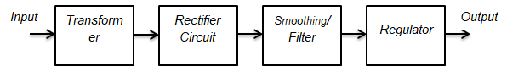

The four main sub blocks are: Transformer, Rectifier Circuit, Filter and Regulator

1. **INPUT TRANSFORMER**

A transformer is a device that is used to step up or step down the AC voltages level, keeping the input and out power the same. AC coming to your home has the voltage level of 220/120 V. We need the input transformer to step down the incoming AC to our required lower-level which is close to 5V (AC). This lower level is further used by other blocks to get the required 5V DC. Since we are using the main supply voltage which is too dangerous. We must never touch any of the terminals with bare hands or with bad instruments and must have a good and decent non-contact voltage tester and use it to always be sure of which line is the live wire coming to the transformerprovide virtual assistance to customers.

1. **RECTIFIER CIRCUIT**

A rectifier circuit is the combination of diodes arranged in such a manner that converts AC into DC voltage. The transformer still didn’t step down the voltage to 5V DC. The stepped-down voltage is still AC and need to convert it into DC for a good rectifier circuit. Without the rectifier circuit, it is not possible to have the required output 5V DC voltage.

1. **FILTER**

A capacitor filter is used when we need to convert a pulsating DC into pure or to remove distortion from signal. Nothing is ideal in practical electronics. The rectifier circuit converts the incoming AC to DC but it does not make it a pure DC. The output of the rectifier is pulsating and is called pulsating DC. This pulsating DC is not considered good to power up sensitive devices. The rectified DC is not very clean and has ripples and the job of the filter is to filter out these ripples and to make the voltage compatible for regulation. A rule of thumb is DC voltage must have less than 10 percent ripples to be regulated perfectly. The best filter in our case is the capacitor and the capacitor is used to charge the storing

## CHAPTER - 3

## 3.1. REDUCED HUMAN EFFORT

The faults in underground cables disturb the stability and reliability of the power system. The modeling of a DWT is not enough to determine the location of the fault and speed up the necessary action. In this regard, a novel method is proposed that consists of the current relay and timing coordination as the protection coordination, and DWT methodology for the faulty-section detection.

The design of any circuit begins with a block diagram. It helps us to design the sections of the circuit individually and then at the end put them together to have a complete circuit, ready for use. In this circuit first our requirement is to check 220 volt AC supply status. Firstly we have to convert 220 volt AC to 5 volt DC because our microcontroller can read up to maximum 5 volt DC supply. For step down the supply we are using here is the step down transformer. This transformer will convert 220 AC to 12 volt AC. The next step is converting this AC to DC. For that we are using full wave bridge rectifier and filter for smooth. So now this is 12 volt DC and then using 7805 voltage regulator for convert the 12 volt to 5 volt. After this process this output of voltage regulator will be connected with microcontroller GPIO pin. So microcontroller will able to read the status of supply using that connected pin. According to status of that pin the microcontroller will update the status on IOT cloud. From that we will able to see the status from anywhere of world location.

E-commerce also enables businesses to offer personalized shopping experiences to their customers. By leveraging customer data, businesses can create targeted marketing campaigns and tailor product recommendations to individual customers based on their past purchases and preferences. This not only helps to increase customer satisfaction but also drives customer loyalty and repeat purchases.

Furthermore, e-commerce platforms can offer significant cost savings for businesses. By eliminating the need for a physical storefront, businesses can save on rent, utilities, and other expenses associated with maintaining a brick-and- mortar location. Additionally, e-commerce platforms often offer cost-effective advertising options that can help businesses reach their target audience without breaking the bank.

In conclusion, e-commerce adoption has transformed the way businesses approach their marketing strategy. By leveraging the benefits of e-commerce, businesses can reach new markets, gather valuable customer insights, offer personalized shopping experiences, and save costs. For small businesses in particular, e-commerce offers a level playing field to compete with larger organizations and expand their reach beyond traditional boundaries. As e- commerce continues to evolve, businesses that fail to adopt it may find themselves falling behind in a highly competitive market.

## 3.2. LESS MAINTENANCE

Power supply networks are growing continuously and their reliability getting more important than ever. The complexity of the whole network comprises numerous components that can fail and interrupt the power supply for end user. For most of the worldwide operated low voltage and medium voltage distribution lines, underground cables have been used for many decades. Underground high voltage cables are used more and more because they are not influenced by weather conditions, heavy rain, storm, snow and pollution. Even though the Cable manufacturing technology is improving steadily, there are still influences which may cause cable to fail during test and operation.

A cable in good condition and installed correctly can last a lifetime of about 30 years. However, cables can be easily damaged by incorrect installation or poorly executed jointing, while subsequent third-party damage by civil works such as trenching or curb edging. Fault in cable is represented as any defect and inconsistency, caused by breaking of conductor and failure of insulation and weakness or non-homogeneity that affects performance of cable.

Bundle of electrical conductors used for carrying electricity is called as a cable. An underground cable generally has one or more conductors covered with suitable insulation and a protective cover. Commonly used materials for insulation are varnished cambric or impregnated paper. Fault in a cable can be any defect that can break the path of the performance of the cable. So it is necessary to correct the fault. Power transmission can be done in both overhead as well as in underground cables.

But unlike underground cables the overhead cables have the drawback of being easily prone to the effects of rainfall, snow, thunder, lightning etc. This requires cables with reliability, increased safety, ruggedness and greater service.

Underground cables are preferred in many areas especially in urban places. When it is easy to detect and correct the faults in overhead line by mere observation, it is not possible to do so in an underground cable. As they are buried deep in the soil it is not easy to detect the abnormalities in them. Even when a fault is found to be present it is very difficult to detect fault. This leads to debugging of the entire area to detect fault between two sub section unit, which in turn causes wastage of money and manpower. Clothing and fashion: This category includes clothing, footwear, and accessories such as jewelry and bags.

## 3.3.PROTECTING EQUIPMENT

Fuses are built as a safety measure if there is too much current flowing through a circuit. Fuses have a thin metal strip (usually made of copper or zinc) that keeps the connection open. However, if an electrical current exceeds the maximum current allowed within that fuse it will overheat and cause the metal strip to melt. The destroyed metal strip breaks the connection and stops electricity from flowing through. Fuses are there to protect appliances from electric power surges and overheating which is one of the main causes of electric fires. The fuse has to be replaced after one fault. Check out our [article on fuses](https://east-westelectric.com/upgrade-your-fuse-box/) to learn more.

AFCIs are a special type of electrical safety device. Normal circuit breakers detect faults when the current exceeds the maximum rated value, however, there are faults that occur when this value is not reached. An electric arc fault (or an electric arc flash) occurs when a current flows through an air gap between conductors. These can be caused by dust or corrosion on the surface of the conductor, poor installation of the system, or normal wear and tear of the parts. [AFCIs](https://en.wikipedia.org/wiki/Arc_fault) measure the chopped current wave as opposed to the heat which GFCIs are unable to do. If an anomaly is detected the AFCI will trip and break the connection, preventing an electric fire.

## 3.4.IDENTIFY FAULT LOCATION

Finding the [type of a **fault in underground cables**](http://www.electricaleasy.com/2017/05/faults-in-underground-cables-types-and.html) using a megger should not be a difficult task. But, finding the exact **location of the cable fault** needs special techniques. Two of the popular techniques are the [Murray and Varley loop tests for locating faults](http://www.electricaleasy.com/2017/06/loop-tests-for-locating-faults-in-underground-cables.html) in [underground cables](http://www.electricaleasy.com/2017/03/underground-power-cables.html). This article explains about few other popular **techniques for locating faults in underground cables** - viz.

A cablethumper is basically a portable high voltage surge generator. It is used to inject a high voltage DC surge (about 25 kV) into the faulty cable. If you supply a sufficiently high voltage to the faulty cable, the open-circuit fault will break down creating a high-current arc. This high current arc makes a characteristic thumping sound at the exact location of the fault.

To find the locationofcablefaultusingthethumpingmethod, a thumper is set to thump repeatedly and then walking along the cable route to hear the thumping sound. The higher the dc voltage applied, the louder will be the resulting thump. This method is useful for relatively shorter cables. For longer cables, the thumping method becomes impracticable (imagine walking along a cable that runs several kilometers to hear the thump).

## CHAPTER - 4

## 

## BLOCK DIAGRAM

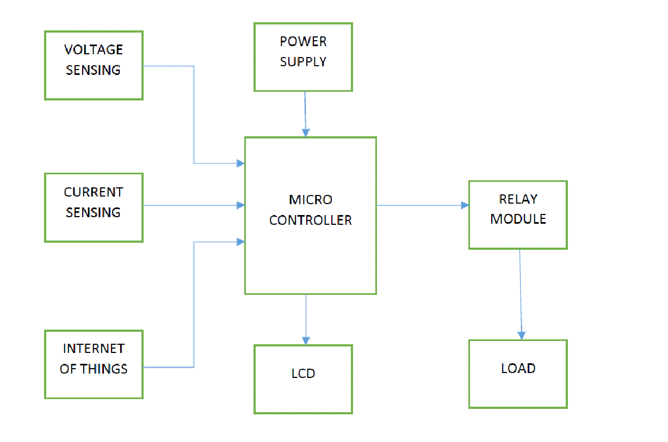

The design of any circuit begins with a block diagram. It helps us to design the sections of the circuit individually and then at the end put them together to have a complete circuit, ready for use. In this circuit first our requirement is to check 220 volt AC supply status.

Firstly we have to convert 220 volt AC to 5 volt DC because our microcontroller can read up to maximum 5 volt DC supply. For step down the supply we are using here is the step down transformer. This transformer will convert 220 AC to 12 volt AC.

The next step is converting this AC to DC. For that we are using full wave bridge rectifier and filter for smooth. So now this is 12 volt DC and then using 7805 voltage regulator for convert the 12 volt to 5 volt. After this process this output of voltage regulator will be connected with microcontroller GPIO pin.

So microcontroller will able to read the status of supply using that connected pin. According to status of that pin the microcontroller will update the status on IOT cloud. From that we will able to see the status from anywhere of world location

## FLOW DIAGRAM/FLOW CHART

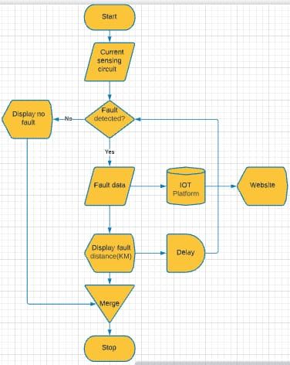The flow chart of the logic behind the fault detecting system is given in Figure The input and output ports of Microcontroller, LCD display, RTC and RELAY module of the system are configured and initialized. When fault occurs (switch is pressed), the fault distance, time and phase are displayed corresponding to that fault. The above fault information will be displayed in the LCD using 12*6 LCD module

For the real worldwide operated voltage distribution lines underground cables have been used from many years. In order to reduce the sensitivity of distribution networks to environmental influences underground voltage cables are highly used. Underground cables have been widely used in power distribution networks due to the advantages of underground connection. Underground cable system is a common practice followed in urban areas. While a fault occurs due to many reasons in the cable, at a time of removing or repairing process, there is difficulty in locating also nearby location of the fault. The system proposed in this project is used to find out the sub area of the fault and display it to the application over internet using Wi-Fi module.

can sell a wider range of products without incurring the costs associated with opening new physical stores. This has given businesses the ability to reach a broader market without significant investments in real estate.

Main supply will apply to step down transformer which results in decrease in power. The power will be applied to rectifier bridge for the conversion of ac to dc. The signal passes through the filter and then it will be passed through the voltage sensor (voltage divider or voltage regulator). The microcontroller checks the status and the information are sent to the cloud.

## SYSTEM OVERVIEW

Power supply networks are growing continuously and their reliability getting more important than ever. The complexity of the whole network comprises numerous components that can fail and interrupt the power supply for end user. For most of the worldwide operated low voltage and medium voltage distribution lines, underground cables have been used for many decades. Underground high voltage cables are used more and more because they are not influenced by weather conditions, heavy rain, storm, snow and pollution. Even though the Cable manufacturing technology is improving steadily, there are still influences which may cause cable to fail during test and operation. A cable in good condition and installed correctly can last a lifetime of aboutThe work automatically updates the status of every substation on IOT. The time of occurrence of fault is determined with the help of microcontroller and ESP8266 Wi-Fi module in a webpage or web application. The system helps to quickly repair the fault and to revive back the power system. 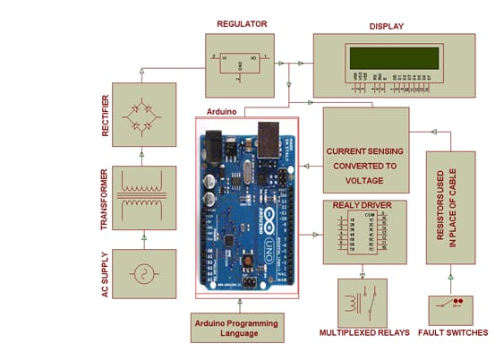

## CHAPTER – 5

## 

## HADWARE DESCRIPTION

♣ ATmega328 Microcontroller The ATmega328 is a single-chip microcontroller. It has a modified Harvard architecture 8- bit RISC processor core. ATmega328 is low-powered and a low-cost microcontroller. ATmega328 has 32KB internal built-in memory. Atmega328 is faster as it uses lesser number of clock cycles for instruction execution.

♣ Arduino Nano Arduino Nano is a small, compatible, flexible and breadboard friendly Microcontroller board, developed by Arduino.cc in Italy, based on ATmega328p / Atmega168. It comes with exactly the same functionality as in Arduino NANO but quite in small size. It comes with an operating voltage of 5V and the input voltage can vary from 7 to 12V.

♣ IoT Module (ESP8266) The ESP8266 is a low-cost Wi-Fi microchip and 1 MiB (Mebibyte) of built-in flash, allowing single-chip devices capable of connecting to Wi-Fi. This small module allows microcontrollers to connect to a Wi-Fi network and make simple TCP/IP connections. The ESP8266 is a small WIFI module built around the ESP8266 chip that can connect microcontroller to the internet wirelessly for a very small cost. Interfacing the ESP8266 with an Arduino and perform some basic functions like connecting it to a WIFI network.

♣ Other Components Step Down Transformer, Rectifier, Filter, Voltage Regulator, Switches and Connecting Wires.

As more buildings and areas are being covered with power line systems, the number and severity of power outages become more serious leading to lower system’s reliability. Reliability is important as it causes serious negative impacts on public health and economical systems. Integration of IoTs technology together with the power grid, aims to improve the reliability of power grids through a continuous monitoring of transmission lines status; in addition to environmental behaviours and consumers activities to send periodic reports to the grid control units. The control units process and extract information from the reported data in order to detect faults, isolate the fault, and then resolve faults intellectually performing energy restoration in smart grid must take into the account the location criticality of blackouts. For examples, it is critical to guarantee high reliability for health and industrial systems. The restoration problem becomes a very complex problem when taking into the consideration the large number of combinations of switching operations which exponentially increases with the increase in system’s components. Designing the smart grid in a hierarchical model divides the problem into multiple control units in charge of restoring power within its region or scope.

## SOFTWARE DESCRIPTION

♣ Arduino IDE The Arduino integrated development environment (IDE) is a cross-platform application for (Windows, macOS, Linux). The Arduino IDE supports the languages C & C++. Arduino also simplifies the process of working with microcontrollers.

♣ Embedded C Embedded C is a set of language extensions for the C programming language. It addresses commonality issues that exist between C extensions for different embedded systems. It includes a number of features not available in normal C, such as fixed-point arithmetic, named address spaces and basic I/O hardware addressing. Embedded C uses most of the syntax and semantics of standard C.

There are two main types of chatbots: rule-based and AI-based. Rule-based chatbots use pre-defined rules and scripts to respond to user inputs, while AI- based chatbots rely on machine learning algorithms to analyze and understand user input, and generate more personalized responses. AI-based chatbots can also learn and improve over time, making them more effective at handling complex queries and providing accurate responses.

## ARDUINO IDE

Arduino Nano is programmed using Arduino IDE which is an Integrated Development Environment that runs both offline and online.

* No prior arrangements are required to run the board. Components needed are board, mini USB cable and Arduino IDE software installed on the computer. USB cable is used to transfer the program from computer to the board.
* No separate burner is required to compile and burn the program as this board comes with a built-in boot-loader.

**5.3.1 ARDUINO CODE USING C PROGRAM**

#define F_CPU 16000000UL

#include <avr/io.h>

#include <util/delay.h>

#include <stdio.h>

#include <stdlib.h>

#define ADC_Pin PA0 //Defining the analogue input port

#define B5 PB5 //relay driver input

#define B6 PB6

#define B7 PB7

#define LCD_PORT PORTC

#define LCD_DDR DDRC

#define LCD_PIN PINC

#define RS PC2

#define EN PC3

uint8_t customChar[] = { //Enumerated character

0x00,

0x1B,

0x15,

0x11,

0x0A,

0x04,

0x00,

0x00

};

void LCD_cmd(unsigned char cmd){

LCD_PORT=(LCD_PORT & 0x0F)|(cmd & 0xF0);

LCD_PORT &=~(1<<RS);

LCD_PORT |=(1<<EN);

_delay_us(100);

LCD_PORT &=~(1<<EN);

_delay_us(100);

LCD_PORT=(LCD_PORT & 0x0F)|(cmd<<4);

LCD_PORT |=(1<<EN);

_delay_us(100);

LCD_PORT &=~(1<<EN);

}

void LCD_data(unsigned char data){

LCD_PORT=(LCD_PORT & 0x0F)|(data & 0xF0);

LCD_PORT |=(1<<RS);

LCD_PORT |=(1<<EN);

_delay_us(100);

LCD_PORT &=~(1<<EN);

_delay_us(100);

LCD_PORT=(LCD_PORT & 0x0F)|(data<<4);

LCD_PORT |=(1<<EN);

_delay_us(100);

LCD_PORT &=~(1<<EN);

}

void LCD_init(){

LCD_DDR=0xFC;

LCD_PORT &=~(1<<EN);

_delay_ms(2);

LCD_cmd(0x33);

_delay_us(100);

LCD_cmd(0x32);

_delay_us(100);

LCD_cmd(0x28);

_delay_us(100);

LCD_cmd(0x0C);

_delay_us(100);

LCD_cmd(0x01);

_delay_ms(2);

LCD_cmd(0x06);

_delay_us(100);

}

void LCD_gotoXY(unsigned char x, unsigned char y){

unsigned char firstCharAdr[]={0x80,0xC0,0x94,0xD4};

LCD_cmd(firstCharAdr[y-1]+x-1);

_delay_us(100);

}

void LCD_string(char *str){

unsigned char i=0;

while(str[i]!=0){

LCD_data(str[i]);

i++;

}

}

void LCD_customChar (unsigned char loc, unsigned char *msg)

{

unsigned char i;

if(loc<8)

{

LCD_cmd(0x40 + (loc*8)); /* Command 0x40 and onwards forces the device to point CGRAM address */

for(i=0;i<8;i++)

{ /* Write 8 byte for generation of 1 character */

LCD_data(msg[i]);

}

}

}

void ADC_init()

{

ADCSRA |=((1<<ADEN)|(ADPS2)|(1<<ADPS1)); /* ADC Prescaling =64 */ //free running mode

//ADCSRA|=(1<<ADEN)|(1<<ADPS2)|(1<<ADPS1)|(1<<ADPS0); // Enable ADC also set Prescaler as 128

ADMUX |=(1<<REFS0); /* Reference voltage on VCC */

}

uint16_t ADC_read(uint8_t channel)

{

ADMUX=((0xF0 & ADMUX) | channel);//enabling 8bit channel

ADCSRA |=(1<<ADSC);//start conversion

while(!(ADCSRA&(1<<ADIF)));//wait for adif conversion complete return

//ADCSRA|=(1<<ADIF);//clear adif when conversion is complete

return(ADC);

}

int main(void)//main entry to the program

{

DDRA &=~(1<<ADC_Pin);//set PORTA0 as input

ADC_init();

int ADC_Value=0 ; // define an integer to save adc read value

LCD_init();

LCD_customChar(0,customChar);

while(1)

{

LCD_gotoXY(1,1);

LCD_string("IOT system");

_delay_ms(10);

LCD_gotoXY(1,2);

LCD_string("Fault Detection");

_delay_ms(100);

LCD_cmd(0X01);

LCD_gotoXY(1,1);LCD_string("RED");

LCD_gotoXY(6,1);LCD_string("YELLOW");

LCD_gotoXY(13,1);LCD_string("BLUE");

_delay_ms(10);

//LCD_data(0);

PORTB|=(1<<B7);//Output

PORTB&=~(1<<B6);

PORTB&=~(1<<B5);

_delay_ms(100);

ADC_Value = ADC_read(ADC_Pin); //save adc read value in integer

//RED PHASE

if(ADC_Value>=1000)

{

LCD_gotoXY(1,2);

LCD_string("N0FT");

}

else if ((ADC_Value>=890)&&(ADC_Value<=920))

{

LCD_gotoXY(1,2);

LCD_string("2FL");

}

else if ((ADC_Value>=870)&&(ADC_Value<=880))

{

LCD_gotoXY(1,2);

LCD_string("4FL");

}

else if ((ADC_Value>=800)&&(ADC_Value<=825))

{

LCD_gotoXY(1,2);

LCD_string("6FL");

}

else if ((ADC_Value>=670)&&(ADC_Value<=688))

{

LCD_gotoXY(1,2);

LCD_string("8FL");

}

_delay_ms(100);

PORTB&=~(1<<B7);

PORTB|=(1<<B6);//Output

PORTB&=~(1<<B5);

_delay_ms(100);

ADC_Value = ADC_read(ADC_Pin); //save adc read value in integer

//YELLOW PHASE

if(ADC_Value>=1000)

{

LCD_gotoXY(7,2);

LCD_string("NOFT");

}

else if ((ADC_Value>=890)&&(ADC_Value<=920))

{

LCD_gotoXY(7,2);

LCD_string("2FL");

}

else if ((ADC_Value>=870)&&(ADC_Value<=880))

{

LCD_gotoXY(7,2);

LCD_string("4FL");

}

else if ((ADC_Value>=800)&&(ADC_Value<=825))

{

LCD_gotoXY(7,2);

LCD_string("6FL");

}

else if ((ADC_Value>=670)&&(ADC_Value<=688))

{

LCD_gotoXY(7,2);

LCD_string("6FL");

}

_delay_ms(100);

PORTB&=~(1<<B7);

PORTB&=~(1<<B6);

PORTB|=(1<<B5);//Output

_delay_ms(100);

ADC_Value = ADC_read(ADC_Pin); //save adc read value in integer

//BLUE PHASE

if(ADC_Value>=1000)

{

LCD_gotoXY(13,2);

LCD_string("NOFT");

}

else if ((ADC_Value>=890)&&(ADC_Value<=920))

{

LCD_gotoXY(13,2);

LCD_string("2FL");

}

else if ((ADC_Value>=870)&&(ADC_Value<=880))

{

LCD_gotoXY(13,2);

LCD_string("4FL");

}

else if ((ADC_Value>=800)&&(ADC_Value<=825))

{

LCD_gotoXY(13,2);

LCD_string("6FL");

}

else if ((ADC_Value>=670)&&(ADC_Value<=688))

{

LCD_gotoXY(13,2);

LCD_string("8FL");

}

_delay_ms(100);

LCD_cmd(0X01);

_delay_ms(100);

}

return 0;

}

## SIMULATION DIAGRAM

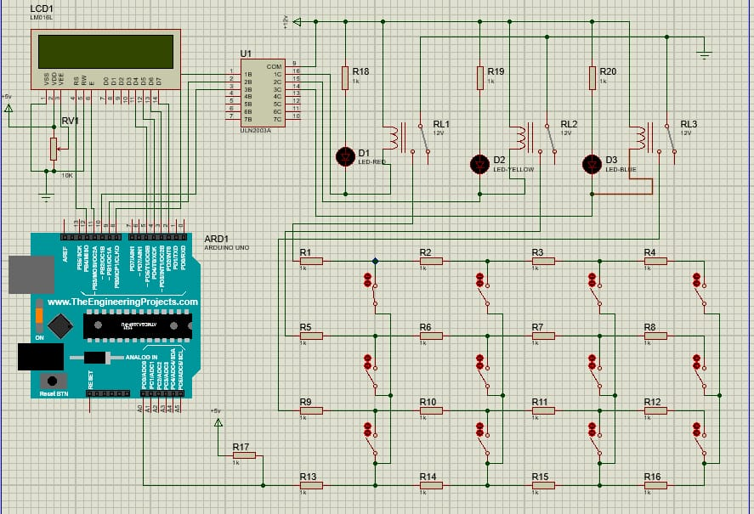

## CHAPTER – 6

1. **ADVANTAGES &APPLICATION**

Numerous techniques are being polished during the most recent couple of decades for cable line shortcoming recognition. The most widely recognized strategy being utilized is overhead cable lines. The deficiencies are handily recognized in this technique however the issue in this strategy is that in some overpopulated urban areas we cannot utilize this technique. So we utilize underground cables. IoT innovation has been actualized in this paper which will examine over the deficiencies over web and this can be observed by a person. With the assistance of potential divider arrange over the cable the framework will have the option to recognize the shortcoming. When an issue is made at a juncture shorting two lines together ,a specific measure of power gets created according to the resistor organize blend. Since existing framework is not effective ,in this paper we propose a framework dependent on IoT. The goal of this venture is to discover the separation of the underground cable shortcoming from base station in kilometers utilizing an IoT Gecko stage. The underground cableline framework isn't exceptionally well known in provincial territories however are being utilized in numerous urban regions. Different flaw finding strategies like the sectionalizing techniques, acoustic location strategy, Murray circle techniques are not utilized much by and because they have numerous impediments. Most usually blames happen because of development works and different reasons. It is hard to uncover cable lines totally as we don't have the foggiest idea about the specific area of the cable line shortcoming. On the off chance that the issue had happened because of voltage across arrangement resistors changes likewise. This voltage is detected by the microcontroller and is refreshed to the client. The data passed on to the client is the separation to which that voltage compares to the flaw happening at a specific separation and the individual stage is on LCD

# CHAPTER - 7

## COMPONENTS AND WORKING

**7.1 MICROCONTROLER**

**7.2 SNSORS**

|  |  |
| --- | --- |
|  |  |
| Diode | IN4007 |
| Capacitor | 22pF |
| Resistor | 1k |
| Resistor | 470 |
| Resistor | 10k |
| LED | 3 |
| BJT | BC547 |
| Arduino | UNO R3 |
| Crystal | 16MHZ |
| Relay | 12V |
| Push buttons |  |
| IC base |  |
| PCB |  |
| Wires |  |

* 1. **LCD DISPLAY**

LCD Display LCD includes two glass boards, with the fluid gem material in the middle of them. The inward surface of the glass plates are covered with anodes. This LCD display is used to display the fault locations occurred in the underground cable system. Using an LCD display the user can easily know where the defect is located and can repair it easily:

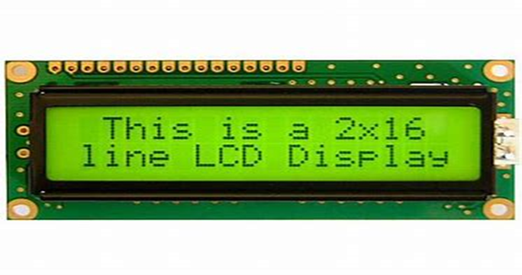

## 7.4 CIRCUIT DIAGRAM

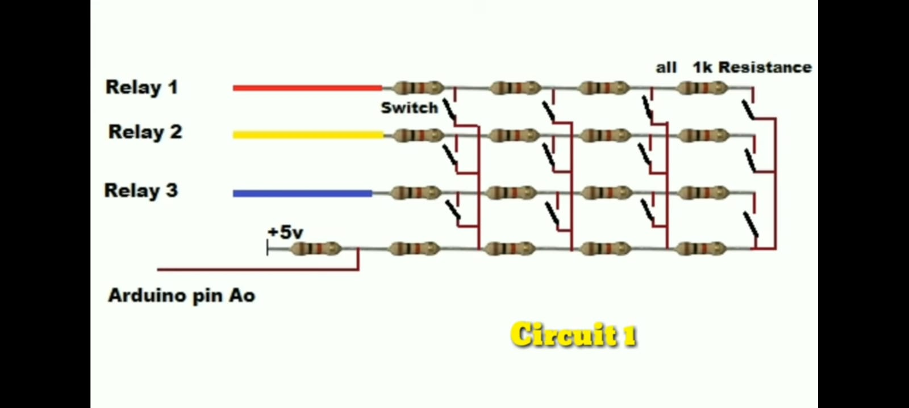

**CIRCUIT DIAGRAM 2**

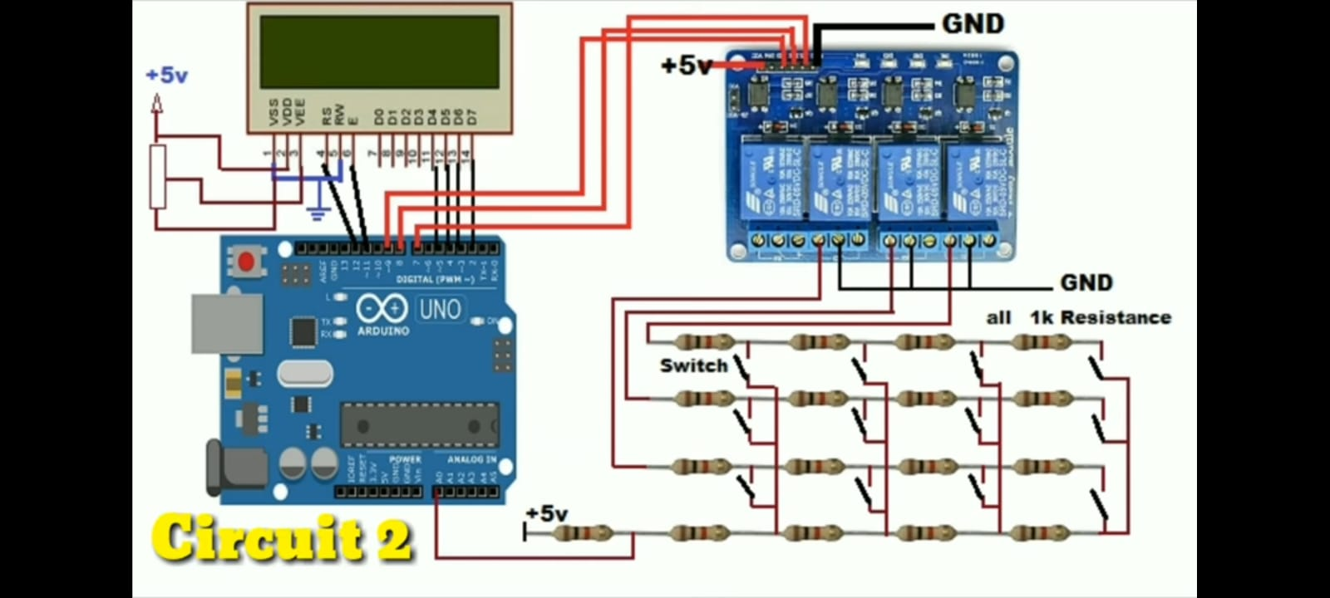

# CHAPTER – 8

## 8.1 CONCLUSION

The work automatically sends data to cloud about fault with the help of Atmega328 and ESP8266 RELAY module in a webpage or IOT application. Underground high voltage cables are used more and more because they are not influenced by weather conditions, heavy rain, storm, snow and pollution. However, cables can be easily damaged by incorrect installation or poorly executed jointing, while subsequent third-party damage by civil works such as trenching or curb edging. Fault in a cable can be any defect that can break the path of the performance of the cable. So it is necessary to correct the fault. Underground cables are preferred in many areas especially in urban places. With the help of this system, we can get to know the location of the fault in the cable which are buried under ground. Therefore, this system does not lead to debugging of the entire area to detect the fault. Hence, the expenditure and manpower gets reduced. The benefits of fault are fast repair to revive back the power system and improves the system performance. It reduces the operating expense and the time to detect the faults in the field. The Arduino microcontroller works based on the output of power supply status. The IOT module is vital due to which it can quickly update the status on IOT and many substation which can be done through common app of IOT.

**8.2 FUTURE SCOPE**

This project is capable to measure open circuit fault and short circuit fault.

1. Open Circuit Fault:

Open Circuit can be detected by measuring the capacitance between two wires. Capacitance of cable changes according to the length. The length of cable varies based on the location of cable cut (open). As the cable is open parallel wire capacitance gets reduced based on this, we can calculate the fault location.

2. Short Circuit Fault:

Short circuit can be determined by measuring resistance between two cables at one end (base station). The value of resistance tells us the exact location of short circuit.

The proposed system is to find the exact location of the fault. The project uses the standard concept of Ohms law i.e., when a low DC voltage is applied at the feeder end through a Cable lines, then current would vary depending upon the location of fault in the cable. In case there is a short circuit (Line to Ground), the voltage across series resistors changes accordingly, which is then fed to inbuilt ADC of Arduino board.

## 8.3 REFERENCES

1. **Kunal Yogeshkumar Parikh, Brajesh Kumar and Vijay Raval, “GSM Based Underground Cable Fault Distance Locator”, International Journal for Scientific Research & Development (IJSRD), Vol 6, Issue 4, 2018, pp 1174- 1176.**

## Faizan Mohammad Yakub and Dinesh Rojatkar, “Arduino Cable Fault Detector A Survey”, Vol 4, Issue 1, January 2017 JETIR, pp 2349-5162.

1. **Samuel A. Isaac, Olajube Ayobami, Awelewa Ayokunle, Utibe Bassey, Arduino Microcontroller Based Underground Cable Fault Distance Locator, International Journal of Mechanical Engineering and Technology, 10(3), 2019, pp. 890-902.**
2. **Tanmay Kedia, Abhijeet Lal and Dr. Abhishek Verma. A paper on “IoT Technology Based Underground Cable Fault Distance Detection System Using ATmega328P Microcontroller”, published during 2018**.
3. **Manish Paul, Raj Kamal Kakoti, “Underground Cable Fault Locator”, IARJSET, Vol.3, Issue 9, September 2016**
4. . **Westrom, Arthur C., and James W. Larsen, "Fault distance locator for underground cable circuits" , U.S. Patent No. 5,600,248. 4 Feb. 1997.**
5. **Schulze, Member, IEEE and Peter Schegner, ”Two Terminal Fault Location on Unsymmetrical Transmission Lines”,IEEE,2010**
6. **.B. Clegg, Underground Cable Fault Location. New York: McGraw- Hill, 1993**
7. **Underground Distribution System Design and Installation Guide, Washington D.C.: National Rural Electric Cooperative Association, 1993.**
8. **Rosevear R. D., “Overview of cable engineering”, IEE Colloquium on Supertension, Nov. 1995, pp. 1/1-1/3.**